# User guide

## Software preparation

Our code is written in C++ language under the Ceemple environment. (**If you want to run our code on Microsoft Visual Studio or in other environments, please install OpenCV library first. Then, add our code to your project by yourself and jump to “Testing sequence preparation” directly!**)

* The Ceemple environment can be downloaded from the following website: <https://www.ceemple.com/getceemple/>. The website may be seen as follows. Please download the **Ceemple OpenCV IDE** and install it on “D:\Ceemple\”.

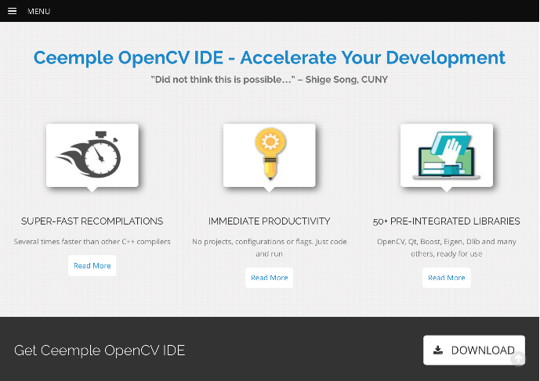

* After you have installed the Ceemple environment, copy the code folder “**AFH_Sugeno_Demo**” into the directory “**D:\Ceemple\user\**”. Then, the user folder may be looked at as follows:

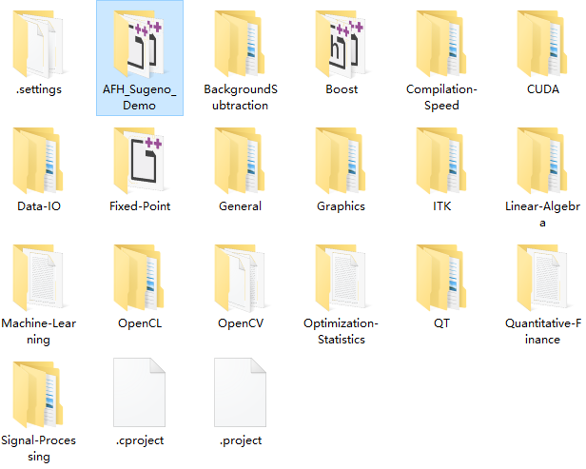

## Testing sequence preparation

Cope the “**AFH_demo**” folder to “**D:\**”. There are three sub-folders in “AFH_demo”: “**learnFolder**”, “**resultFolder**”, and “**segmFolder**”.

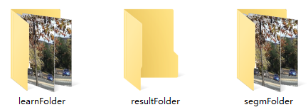

* Put **learning frames** into the “**learnFolder**”. Any kind of image format and any kind of image name is ok.

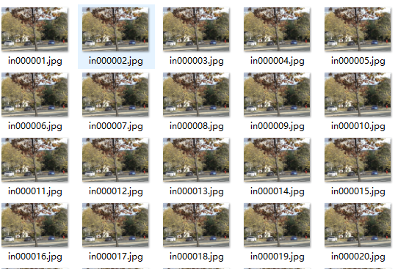

* Put **segmentation frames** into the “**segmFolder**”. Any kind of image format and any kind of image name is ok.

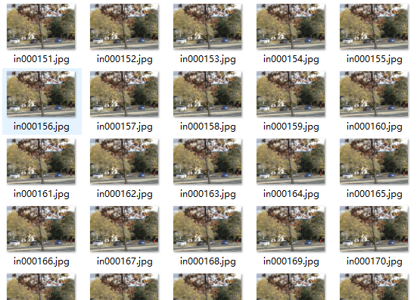

* Leave the “**resultFolder**” **empty**.
* **If you would have intended to use videos for segmentation, please transform the video into image frames first!**

## Run the program

* Open the Ceemple environment and you will see our demo folder as follows. Open the “**Demo_main.cpp**” by double clicking on it. Then, you will see the main function.

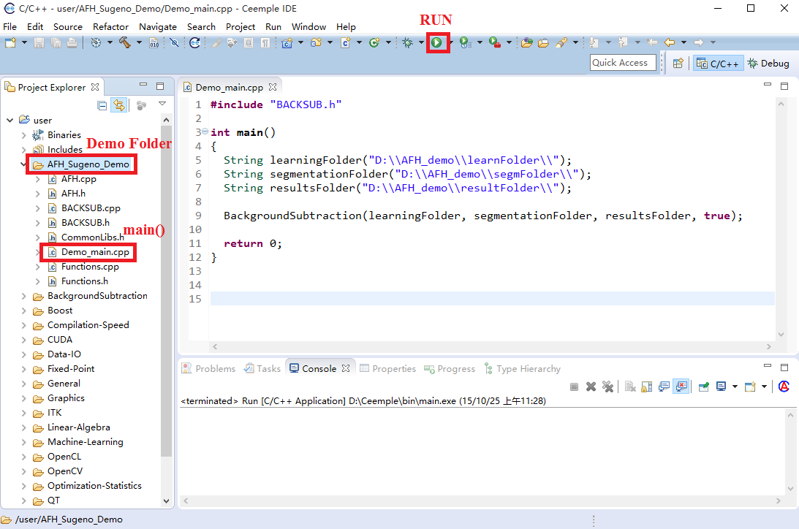

* Click the **run button** and the learning process begin. In the learning process, only the BGR image window occurs.

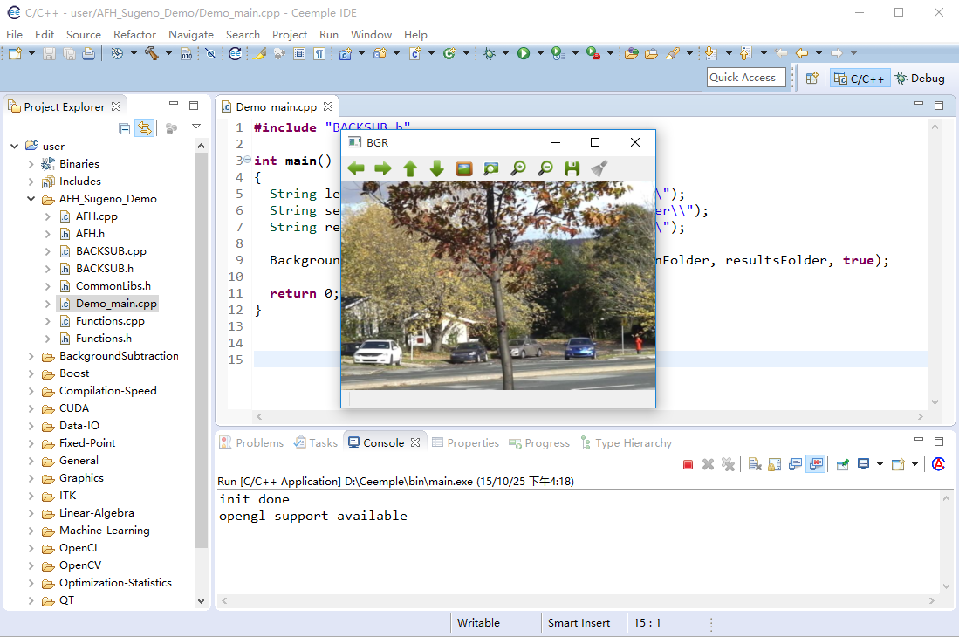

* After the learning process, the segmentation begins automatically. In the segmentation stage, both the BGR image and the binary segmentation result are shown.

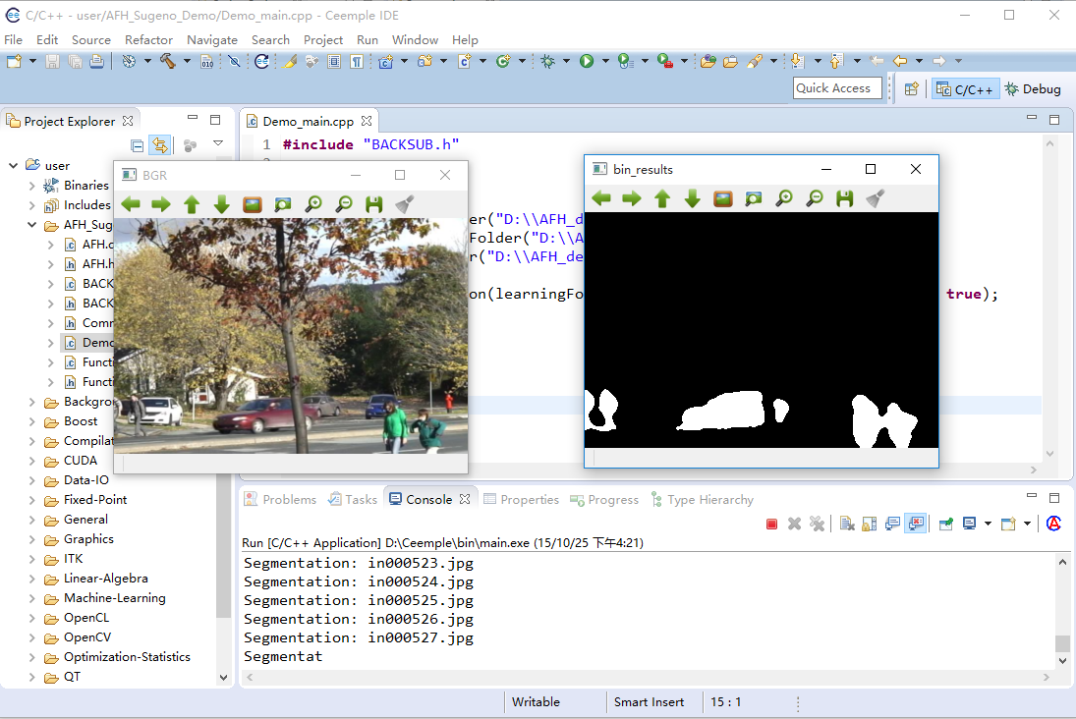

* When the segmentation is over, check the “**resultFolder**” for recorded results.

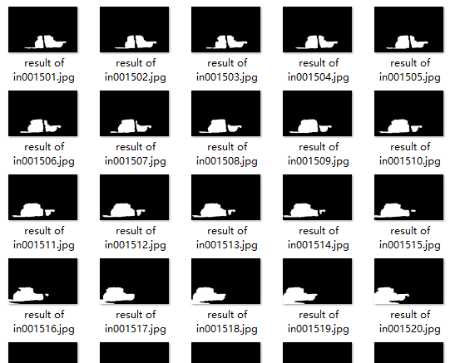

## Links for some other testing sequences

Some open datasets can be downloaded from the following links.

* CDnet: <http://www.changedetection.net/>
* BMC2012: <http://bmc.iut-auvergne.com/>
* Fish4Knowledge: <http://f4k.dieei.unict.it/datasets/bkg_modeling/>
* Mar: <http://www.dis.uniroma1.it/~labrococo/MAR/dataset.htm>
* Wallflower: <http://research.microsoft.com/en-us/um/people/jckrumm/WallFlower/>

## Links for some other open source state-of-the-art

<https://github.com/andrewssobral/bgslibrary/tree/opencv3>